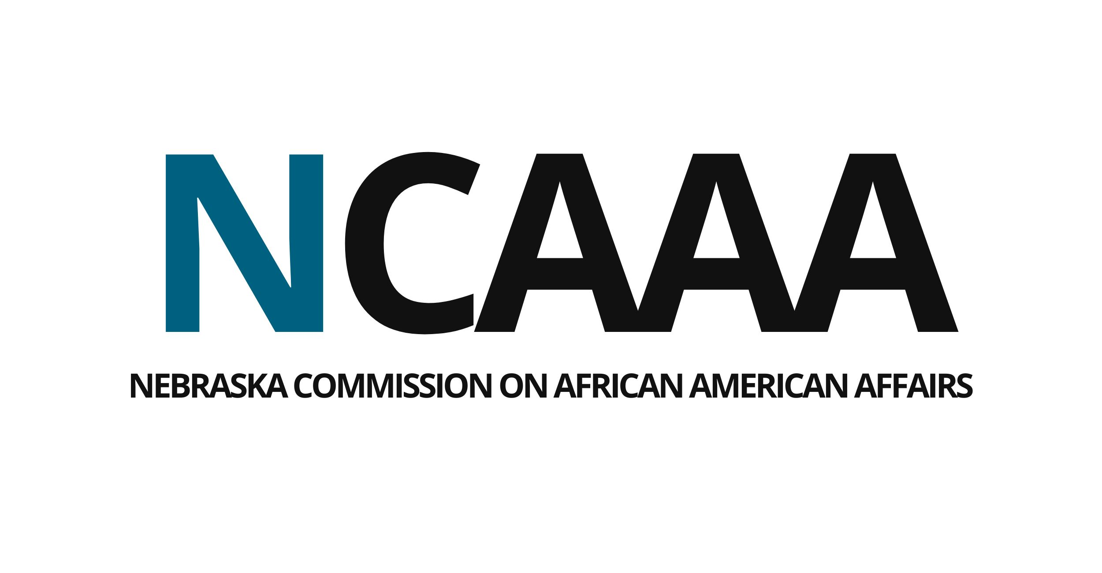

MEETING MINUTES
Friday, September 12, 2025 | 9:00 – 10:30AM / 3:00 – 4:00PM
Location: 2700 Sylvan Road, Nebraska City, NE 68410, Terrace Room
The official public meeting notice and agenda was published on September 5, 2025, at www.ncaaa.nebraska.gov and at www.nebraska.gov.

Present: Tim Clark | Chair
Eboni Caridine
Lawrence Chatters
JoAnna LeFlore-Ejike
Anthony McLeod
Dexter Myers
Johnny Nesbit, arrived 10:00AM
Jason Roberts
Michael Young

Absent: Tremaine Combs
Ted Lampkin
Clarice Jackson

Key Discussion Points:

- Call to Order
Chairman Tim Clark called the meeting to order at 9:12AM, noting the presence of a quorum of eight.

- Roll Call
Staffer Herbert performed roll call. Attendance is listed above.

- Public Comment
Offer for public comment made. There was no in attendance.

- Approval of Minutes
Motion: A motion was made to approve the July 29th minutes by Commissioner Young and seconded by Commissioner McLeod.
Voting Aye: Caridine; Chatters; LeFlore-Ejike; McLeod; Myers; Roberts; Young.
Voting Nay: None.
Abstain: None.
Motion carried.

- Briefing of New Statute
Staffer Herbert gave a short briefing on changes to the Commission’s authorizing statute through LB69, which took effect on September 3.

- Executive Session

Motion: A motion was made to enter into Executive Session to allow for a discussion of internal surveys about the Commission with the Commission’s strategic planning consultant, Bud Synhorst of Robnik Strategies, by Commissioner Young and seconded by Commissioner Chatters.
Voting Aye: Caridine; Chatters; LeFlore-Ejike; McLeod; Myers; Roberts; Young.
Voting Nay: None.
Abstain: None.
Motion carried.

The Commission entered executive session at 9:40AM.

Motion: A motion was made to exit executive session by Commissioner Young and seconded by Commissioner McLeod.
Voting Aye: Caridine; Chatters; LeFlore-Ejike; McLeod; Myers; Nesbit; Roberts; Young.
Voting Nay: None.
Abstain: None.
Motion carried.

The Commission exited executive session at 10:30AM.

- Recess

Motion: A motion was made to recess for the purpose of holding non-quorum committee meetings to facilitate the retreat by Commissioner Young and seconded by Commissioner Nesbit.
Voting Aye: Caridine; Chatters; LeFlore-Ejike; McLeod; Myers; Nesbit; Roberts; Young.
Voting Nay: None.
Abstain: None.
Motion carried.

The Commission went into recess at 10:35AM.

- End Recess
Motion: A motion was made to end recess by Commissioner Young and Commissioner Nesbit.
Voting Aye: Caridine; Chatters; LeFlore-Ejike; McLeod; Myers; Nesbit; Roberts; Young.
Voting Nay: None.
Abstain: None.
Motion carried.

The Commission reconvened from recess at 3:00PM.

- Chair Report
Chair Clark briefed the commissioners on the opening of executive committee nominations for the election to be held at the October 22 meeting in alignment with the Commission’s bylaws.

Chair Clark discussed the opportunity to sponsor the Omaha NAACP Branch Chapter’s Freedom Fund Banquet at a level of $5,000.

Motion: A motion was made to adopt the following resolution by Commissioner Young and seconded by Commissioner Chatters.

Short title: RESOLUTION AUTHORIZING SPONSORSHIP FOR OMAHA NAACP FREEDOM BANQUET

Whereas, the Nebraska Commission on African American Affairs is committed to the social, political, and economic uplift of the Black Community, and
Whereas, the Omaha Branch of the National Association for the Advancement of Colored People is hosting its Freedom Fund Banquet, November 1, and
Whereas, the Omaha Branch of the NAACP has offered to provide a sponsorship package that includes a table, branding, and more.
Resolved, that the Nebraska Commission on African American Affairs approves the disbursement of $5,000 to fund a sponsorship for the Omaha NAACP.

Voting Aye: Caridine; Chatters; LeFlore-Ejike; McLeod; Myers; Nesbit; Roberts; Young.
Voting Nay: None.
Abstain: None.
Motion carried.

- Treasurer Report
Treasurer Nesbit brought the Commission’s office lease for approval to the Commission.

Motion: A motion was made to approve the office lease by Commissioner Young and seconded by Commissioner Roberts.
Voting Aye: Caridine; Chatters; LeFlore-Ejike; McLeod; Myers; Nesbit; Roberts; Young.
Voting Nay: None.
Abstain: None.
Motion carried.

Treasurer Nesbit then shared a bit about the foregoing budget approval process.

- Discussion on Committee Findings and Board Team Building Exercise
Bud Synhorst shared his excitement about the proceedings of the day and asked Commissioners to share two things about the individuals they lunched with and what they felt their reasons were for joining the Commission.

- Adjournment

Motion: A motion to adjourn was made by Commissioner Nesbit and seconded by Commissioner Caridine.
Voting Aye: Caridine; Chatters; LeFlore-Ejike; McLeod; Myers; Nesbit; Roberts; Young.
Voting Nay: None.
Abstain: None.
Motion carried.

The Nebraska Commission on African American Affairs adjourned at 4:00PM.

