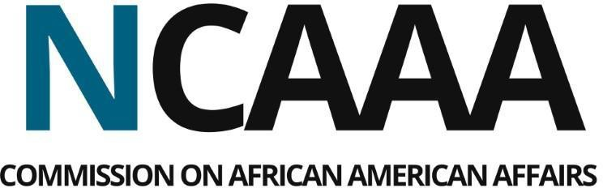

MEETING AGENDA
Wednesday, October 22, 2025 | 3:00 PM - 7:00 PM
Location: Metropolitan Community College, 5730 N 30th St Bldg. 21, Omaha, NE 68111.
The official public meeting notice was published on August 29, 2025, at www.nebraska.gov and at ncaaa.nebrasks.gov, and on October 14, 2025, in the Omaha Star, Omaha World Herald, and Lincoln Journal Star. The meeting agenda was published on October 14, 2025, at www.ncaaa.nebraska.gov.
1 | 3:00 PM | Welcome & Call to Order……………………...……………..Tim Clark, Chairman
2 | 3:05 PM | Roll Call……………………………………...……………….Ted Lampkin, Secretary
3 | 3:10 PM | Public Comments
4 | 3:40 PM | Approval of September 12, 2025, Meeting Minutes………………….Secretary
5 | 3:50 PM | Chairman’s Report……………………………………………….………..Tim Clark
6 | 4:00 PM | Finance Committee Report…………………………..Johnny Nesbit, Treasurer  - Financial Report  - Sponsorship Criteria Update  - Department of Administrative Services MOA
7 | 4:30 PM | Strategic Planning Update…………...……..JoAnna LeFlore-Ejike, Vice Chair
8 | 4:45 PM | Legislative Committee Report………...Lawrence Chatters, Committee Chair
9 | 5:00 PM | BREAK FOR DINNER & COMMISSION HEADSHOTS
10 | 6:00 PM | Commission Elections……………………….…………………………..Tim Clark
11 | 6:45 PM | New Business  - Nebraska Black Elected Leadership Exchange  - Executive Director Search
12 | 7:00 PM | Adjournment

